Bluetooth module arduino
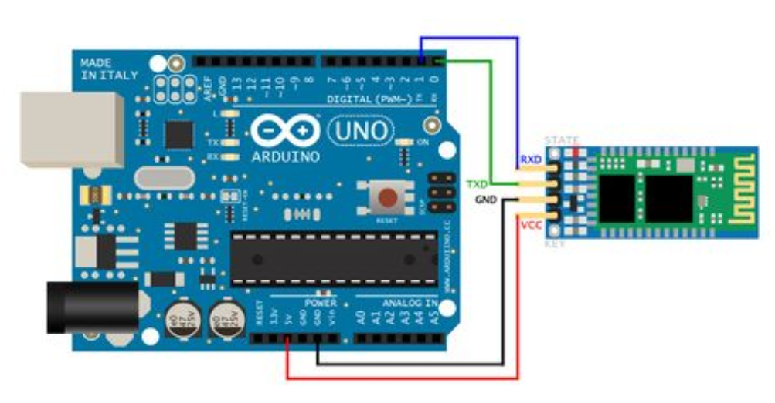
A bluetooth module is a small wireless system that someone has designed , manufactured , and had certified by the FCC , IC , CE , ETSI , etc . Modules are typically small PCB's that include a bluetooth processor , as well as all other hardware needed to run the device . Bluetooth module arduino works on serial communication . The android app is designed to send serial data to the arduino bluetooth module when a button is pressed on the app . You can also open the serial monitor and watch the received data while connecting .

